

|  |  |
| --- | --- |
| **Subject Name:** | Fundamentals of Image Processing |
| **Subject Code:** | BTPR 2053 |

**Group Project**

**By**

|  |  |  |
| --- | --- | --- |
| **Student Name** | **HON JUN YU** | **PANG JIA SHEN** |
| **Student ID** | **B200046A** | **B200048A** |
| **Batch** | **BoSE20-A2** | **BoSE20-A2** |

|  |  |
| --- | --- |
| **Lecturer Name:** | Dr.Pang Yee Yong |
|  |  |

# Introduction

Nowadays, image editing is growing rapidly in technology fields. Actually, the way of how we “edit” an image is through image processing method, which is perform some operations on image to enhance or change the characteristic of the image and extract useful information. We decided to design an application which is similar to “Photoshop” to help user do image processing. User can simply enhance or change the characteristics of the input image through the application. We develop the application by using java programming language and java form.

# Scope

## In Scope

Our application’s functions consist of following techniques:

* Low Pass Filtering
* High Pass Filtering
* Convolution
* Contrast Enhancement
* Halftoning (Patterning, Dithering)
* Tiff File Reading
* Preview Image

## Out of Scope

* Does not support image type other than tiff and raw on image processing

# Application Inteface

## Main Interface

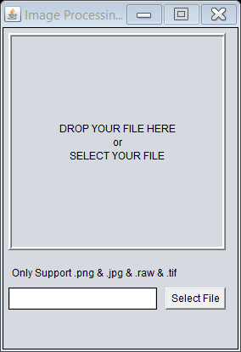

Figure above is the main interface of application, user can drag an image into application or click on “Select File” to choose an image as input. If a jpg/png type image was selected as input, image preview will be appear on the middle of application.

Example: (png image)

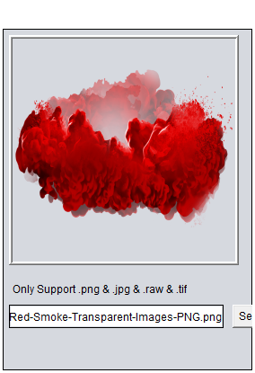

## Tif Reader Interface

Figure 1.2


If an image of tif type was selected as input, interface above will appear to show relevant data information that contain in the tif image. The button “Generate Data” will generate a txt file and store the data information inside.

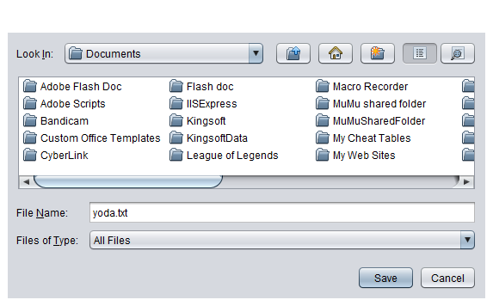

## Raw Image Processing Interface

If an raw type image was selected as input, interface above will show up for the next operations after user type in the correct width and height of the input image. User can choose which type of operations that is needed to perform on the input image, the original image will be shown on left side while image after processed will be shown on right side.

Example: (After halftoning an image by patterning)

# Further Recommendation

In short, our application is just a simply small application for user to do basic image processing operations. This application only consists limited functions which is not a complete image processing tool. There is still space for the application to improve, including support various image types (e.g. jpg) and more operations of image processing available (e.g. high boost filtering). Interface should be more user-friendly which is user able to understand and ease of use. In addition, performance of application will be slow down while loading a larger size of image. We are still unable to fix the problem, but we wish to figure it out in the future and improve the overall performance of application. The problem might be caused by inefficient of algorithm.